**PROJECT REPORT TEMPLATE**

**1. INTRODUCTION :**

**1.1 OVERVIEW**

**My project is DREAM HOMES REALITY I made these project with my team members it is easy to handle and carry accounts.**

* 1. **PURPOSE**

**It is very useful to handle accounts and proper maintain of detail to see bussiness result final output.**

**2. PROBLEM DEFINITION & DESIGN THINKING:**

**2.1 EMPATHY MAP**

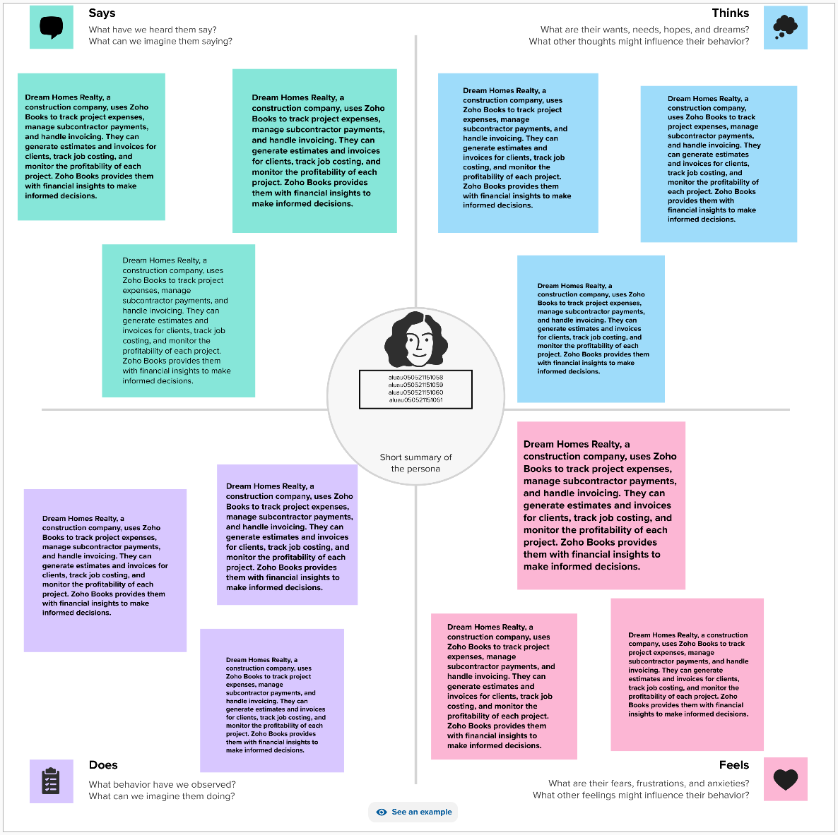

**2.2 IDEATION & BRAINSTORMING MAP**

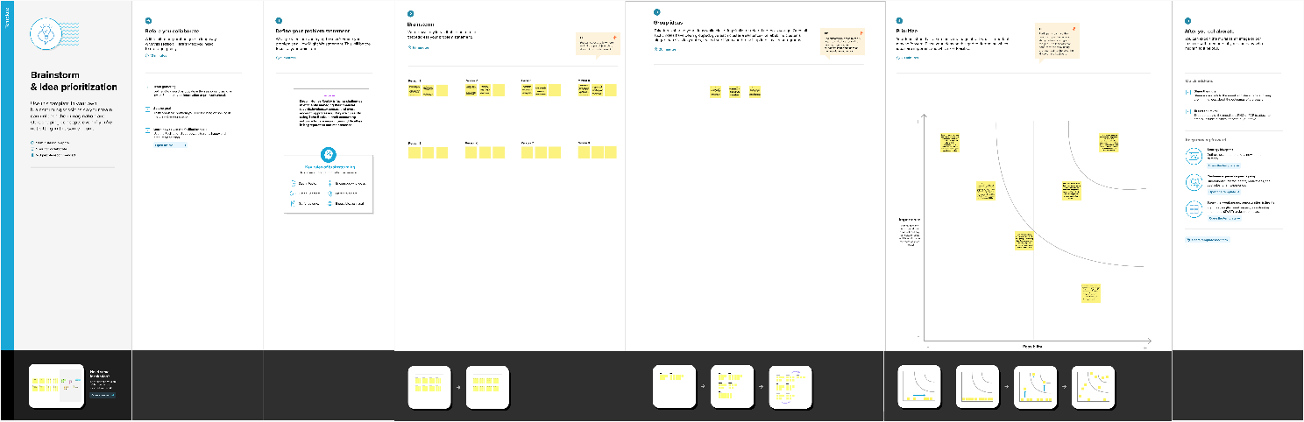

**3. RESULT :**

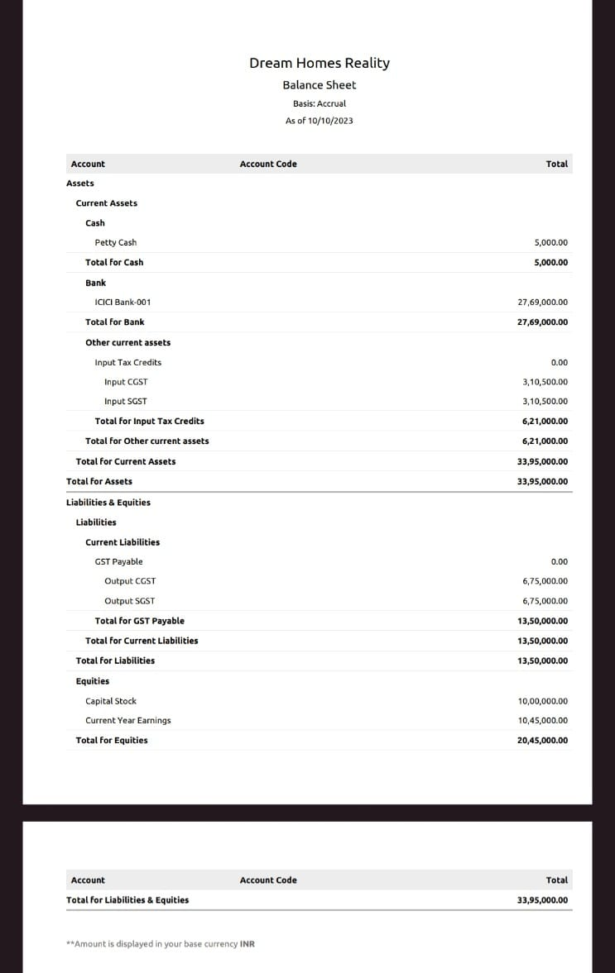

**4.ADVANTAGE & DISADVANTAGE:**

**It is very useful to refer of account and handle manner proper output given.**

**It reduce manual work & security.**

**It is improve account knowledge.**

**5.CONCLUSION:**

**It improve team efficiency and to get good result.**

**6.FUTURE SCOPE:**

**It will get good result in future.**

**It will improve the accounts knowledge and handle manner.**